**DAILY ONLINE ACTIVITIES SUMMARY**

|  |  |  |  |  |  |  |  |  |
| --- | --- | --- | --- | --- | --- | --- | --- | --- |
| **Date:** | **27/5/2020** | | | | | **Name:** | **Banish M G** | |
| **Sem & Sec** | **8th Sem** | | | | | **USN:** | **4AL16CS020** | |
| **Online Test Summary** | | | | | | | | |
| **Subject** | | **IOT** | | | | | | |
| **Max. Marks** | | **30** | | **Score** | | | **28** | |
| **Certification Course Summary** | | | | | | | | |
| **Course** | **Udemy: Python for Data science and Machine Learning** | | | | | | | |
| **Certificate Provider** | | | **Udemy** | | **Duration** | | | **4 hrs** |
| **Coding Challenges** | | | | | | | | |
| **Problem Statement:**  1.  Write a C Program to sort an array of integers in ascending order and display the sorted array and Number of passes performed for sorting. | | | | | | | | |
| **Status:COMPLETED** | | | | | | | | |
| **Uploaded the report in Github** | | | | | **yes** | | | |
| **If yes Repository name** | | | | | B**anish_MG** | | | |
| **Uploaded the report in slack** | | | | | **yes** | | | |

Online Test Details: (Attach the snapshot and briefly write the report for the same)

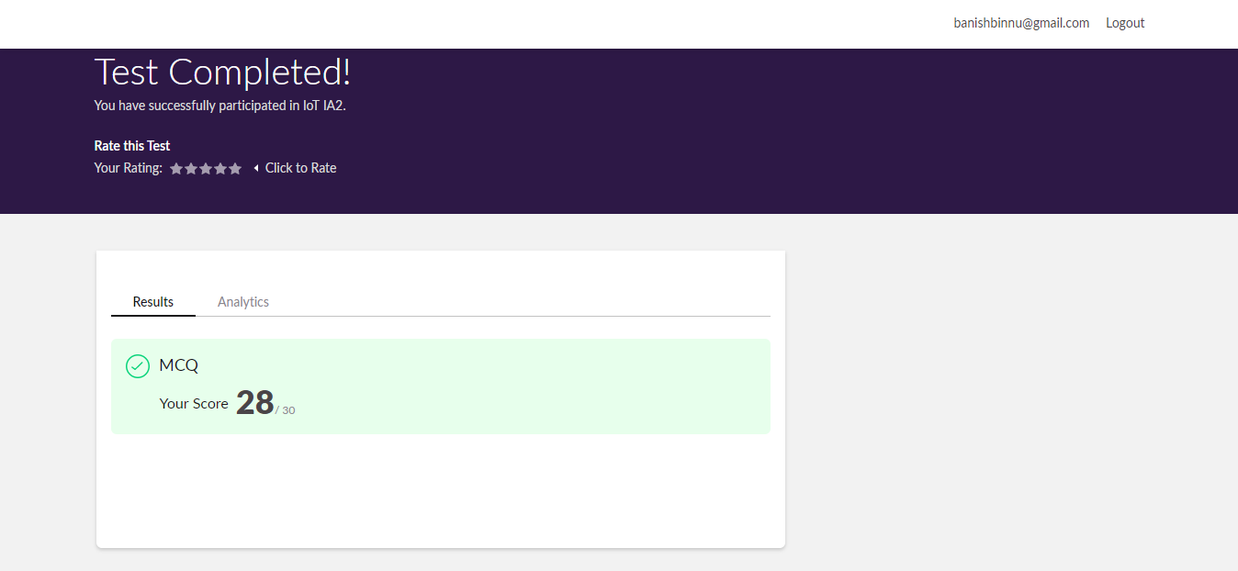

Certification Course Details: (Attach the snapshot and briefly write the report for the same)



Coding Challenges Details: (Attach the snapshot and briefly write the report for the same)

Write a C Program to sort an array of integers in ascending order and display the sorted array and Number of passes performed for sorting.

#include <stdio.h>

void swap(int *xp, int *yp)

{

int temp = *xp;

*xp = *yp;

*yp = temp;

}

// A function to implement bubble sort

void bubbleSort(int arr[], int n)

{

int i, j;

for (i = 0; i < n-1; i++)

// Last i elements are already in place

for (j = 0; j < n-i-1; j++)

if (arr[j] > arr[j+1])

swap(&arr[j], &arr[j+1]);

}

/* Function to print an array */

void printArray(int arr[], int size)

{

int i;

for (i=0; i < size; i++)

printf("%d ", arr[i]);

printf("\n");

}

// Driver program to test above functions

int main()

{

int arr[] = {64, 34, 25, 12, 22, 11, 90};

int n = sizeof(arr)/sizeof(arr[0]);

bubbleSort(arr, n);

printf("Sorted array: \n");

printArray(arr, n);

return 0;

}